*MIS Review*Vol. 22, Nos. 1/2, 2017

Editor’s Introduction

*Eldon Y. Li, Rua-Huan Tsaih*

**Research Articles**

Hidden Topic Analysis for Personalized Document Recommendation

*Te-Min Chang, Wen-Feng Hsiao, Ming-Fu Hsu*

Factors Influencing Consumers’ Attitudes toward Social Media Marketing

*Asad Ahmad, Mohammed Naved Khan*

Human Resource Information System (HRIS): Re-engineering the Traditional Human Resource Management for Leveraging Strategic Human Resource Management

*Abdul Qadir, Swati Agrawal*

Security modeling tool for information systems: Security Oriented Malicious Activity Diagrams Meta Model Validation

*Othmar Othmar Mwambe, Isao Echizen*

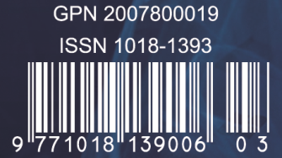

MIS Review

An International Journal

Vol. 22, Nos. 1/2, 2017

*Editor-in-Chief*

Eldon Y. Li, Ph.D.

*Executive Editor*

Rua-Huan Tsaih, Ph.D.



E-ISSN:2218-3450 / ISSN:1018-1393 / GPN:2007800019

Published by Department of Management Information Systems,

College of Commerce, National Chengchi University